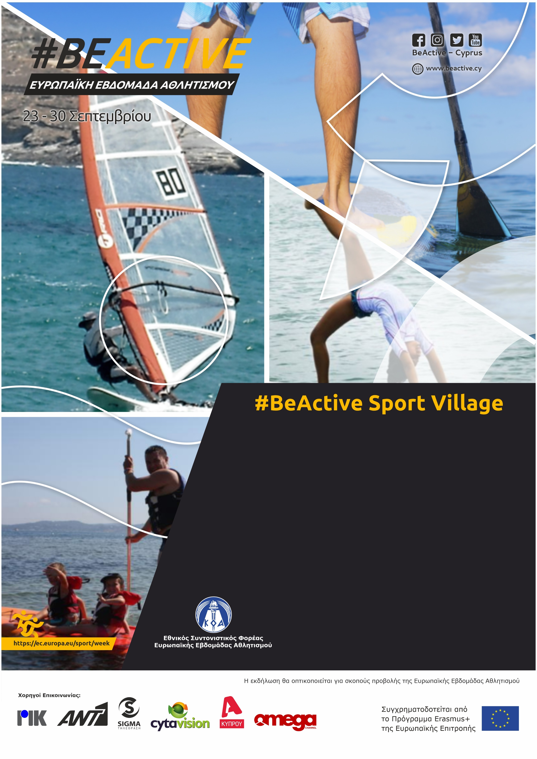

**TIME ATTACK CHALLENGE**

**Time : 10 :00 Date : 23/09/2022**

**Place : Agia Napa**

TEAMS CHALLENGE!!!

Students teams of 10 person each, will challenge their physical abilities and overcome the physical activities obstacles at the beach, competing with Time-Limit.

The Team which finishes First with the best Time wins the Challenge.

**Συν διοργανωτής:**

**Διοργανωτής:**